Project name | Insert project name here | Briefed by | Insert name here
Project number | Insert project number here | Date | Insert date here
Department/agency | Insert cost centre here | Contact details | Insert phone/ email here
Purchase order | Insert PO here, if available | Creative agency | Insert creative agency here
Tiering qualifiers
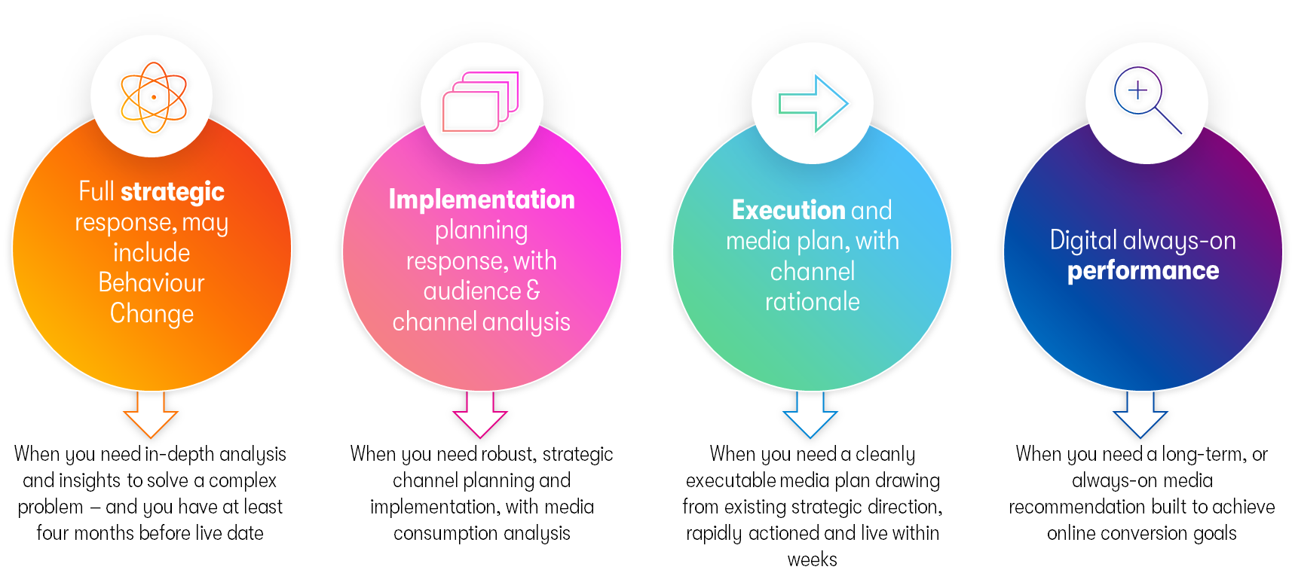

YOU MUST ALLOCATE THIS BRIEF TO A SPECIFIC TIER PRIOR TO OMD COMENCING THE WORK

☐ Strategic Tier ☐ Implementation Tier ☐ Execution Tier ☐ Digital Performance Tier

Decision makers  Insert name here | Stakeholders  Insert name here

Critical problem
Strategic market brief background. What is keeping us awake at night? What are our customers currently doing? What is happening in their systems? What is the behaviour change we’re trying to drive?
Enter here
Objectives
What are the key goals for this campaign?  Enter here | What are the measures of success / key metrics?  Enter here
Marketing and communications task
What do we want our audience to know, intend and/or do as a result of this campaign?
Enter here
Communications approach
Are we looking for big ideas, media partnerships, socially enhanced activities, something to cut-through: shock or engage, content, broadcast initiative, experiential etc.?
Enter here
Deliverables
What do we need the agency to deliver to achieve results?
Enter here
Target audience
Who are we trying to influence? Describe them in terms of demographics, attitudes, size, and behaviour.  Enter here |  | What are the key barriers for our audience?  What and who influences their choices?  Enter here
Insight/s
What is/are the consumer insight/s that drives this brief? Please provide any relevant research or information you have on the behavioural change you are looking to drive.
Enter here
Stages of Change/ Journey
Where in the stages of change/logic model path are we intersecting and influencing our target?
Enter here
Key messages
What are the key messages to be communicated and measured?
Enter here
Creative assets
Are there existing assets that could or should be used as part of this brief?
What creative executions are/will be available?
Enter here
Paid, owned, and earned
Please advise if there is any existing paid activity or earned program of work. What owned assets are available for this campaign (website, signage etc.?)
Enter here
Measurement
Is it website traffic, audience reach, social followers, video views?
KPIs to be included subject to campaign idea.
Enter here
Regions / markets |  | Creative agency
In order of priority  Enter here |  | Who is developing the creative assets?  Enter here
Timings |  | Budget
Enter here |  | Enter here
Mandatories
List any mandatory activity requirements for this brief i.e. TV must be included, social media campaign, content development. Or list what needs to be avoided: no viral video, etc.
Enter here
Any other relevant information?
Enter here

