NSW Government Website Consolidation

Have Your Say consultation editor manual

Table of Contents

Welcome 2
Logging in to Have Your Say 2
Creating a Consultation 6
Editing your Consultation before Submission 11
Submitting Your Consultation for Review 12
Have Your Say Admin Support 13

Welcome

Logging in to Have Your Say

Go to: https://nsw.gov.au/user/login

Enter in your username and password
Click Log in
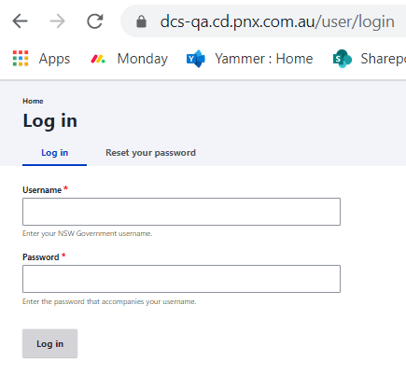

Note: If prompted, tick to Remember my Credentials

Multi Factor Authentication (MFA) is enabled to ensure the NSW Government consolidated website is secure.

This means you must set up an Authenticator App on your mobile device or computer to generate a unique login pin every time you log in to the CMS.

Setting up your Authentication (One time only)
- Go to the login screen for the CMS
https://nsw.gov.au/user

- Enter your login details as usual:
username = firstname.lastname
password = your existing CMS login

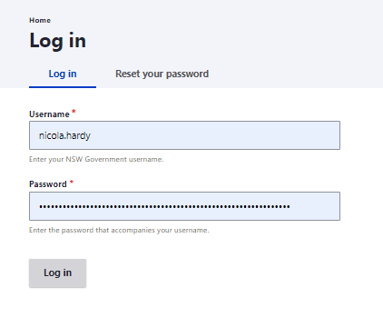

- On your My Workbench homepage you will receive an error message advising you of the change to the login process. Click on the here link to setup your authentication process.

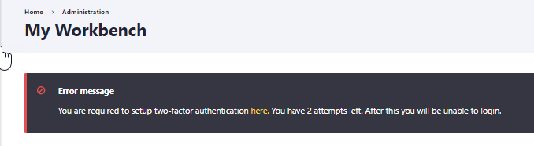

Note: you will need to set up your MFA within 3 logins of this message appearing in your account.

- On your profile settings security tab, click on the link to Set up application
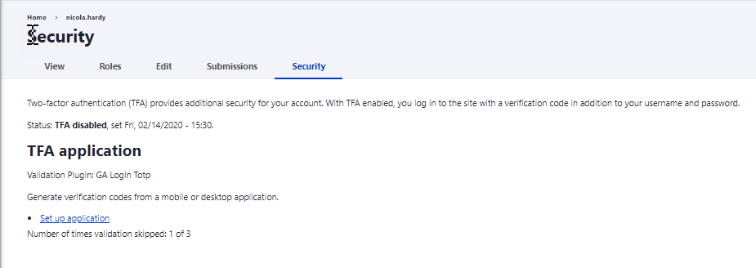

- Re-enter your CMS password.
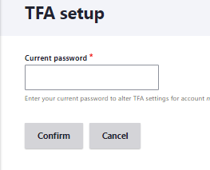

- Download or open a suitable Authenticator App for your mobile or computer from the recommended list on the setup screen.
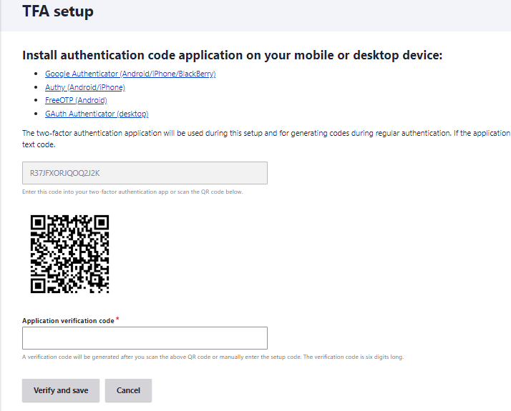

Note: Authy App works well on computers as well as phones, but it will require the temporary use of a mobile phone during setup.

- Follow the prompts to set up your MFA within your chose Authenticator Application. You will either need to enter the two-factor authentication code, or scan the barcode on your MFA setup screen within the CMS to finalise the setup.

- Enter in the Authenticator App Verification Code in the field on the CMS MFA setup screen.

- You will receive a confirmation status once you complete the authentication.
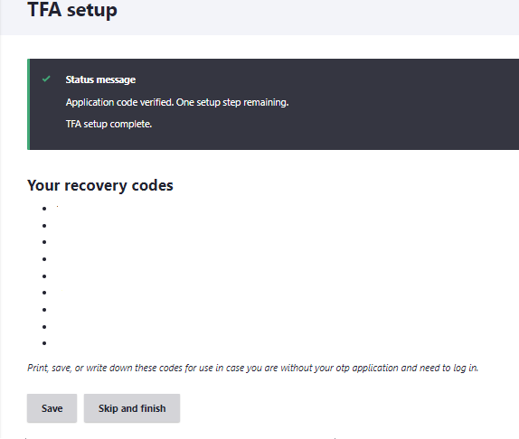

- Optional Step: Right mouse click on the results screen to print to PDF your recovery codes to be safely stored on your computer in case you need help logging in to the CMS in the future.
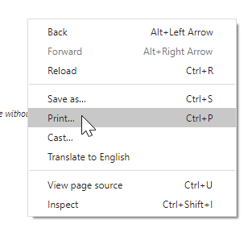
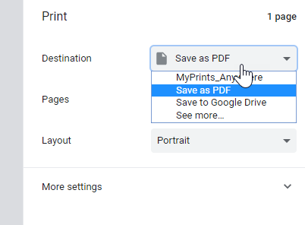

- Congratulations you have finished setting up your MFA. Log out of the CMS to refresh your account.
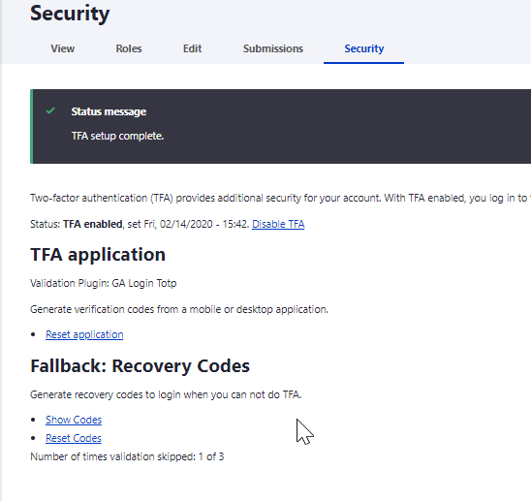

Creating a Consultation

Select the Workbench > Create Content menu
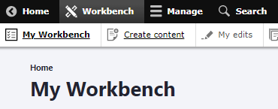

Select Add content > Consultation
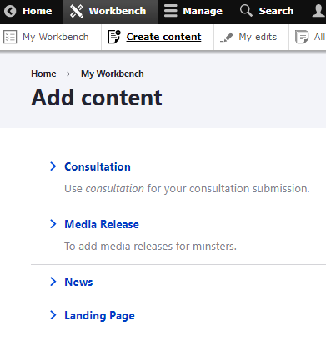

Step 1: Introduction
Add in the Consultation Title – 40 characters max
Note: this will form part of your unique URL

Consultation Summary – a brief intro sentence for the consultation
Consultation Topic – select an option from the pick list

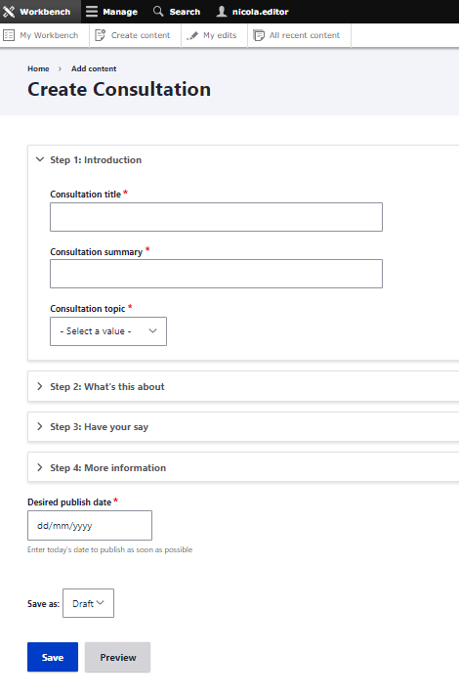

Select Step 2: What’s this about

What’s this about - Enter details about the project in the Consultation introduction
Image – Add a hero image for the consultation
Note: recommended size is 760 p x 440 p
Document – Upload any supporting documents
Note: if you wish to log into an external document or webpage please do so from within the “What’s this about” section above.
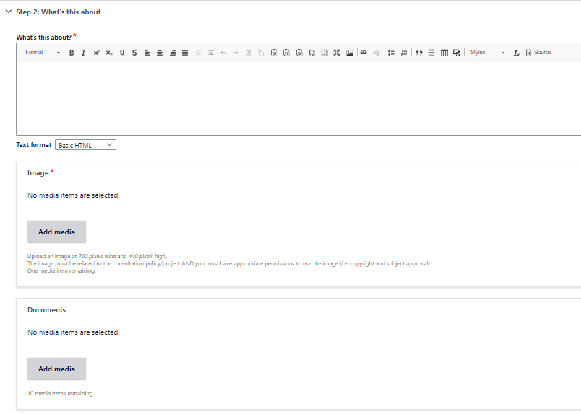

Select the Affected Region/Regions and enter the specific address/location of the project.
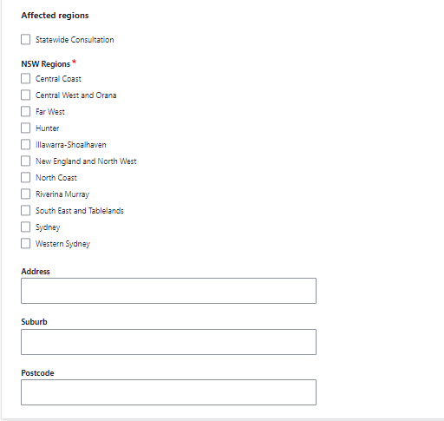

Select Step 3: Have your say
Have your say – detail the consultation process in this section
Method type – select from a drop down and click Add Method
This will show fields relevant to the type of consultation method such as email (an email address and other communication details will be required).
Note: you can add more than one consultation method here.
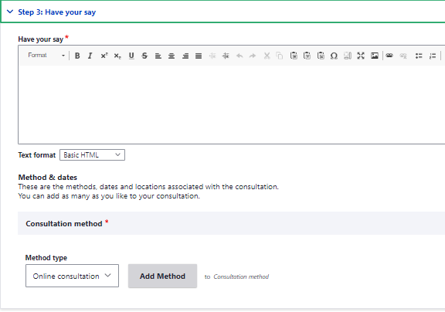

Select Step 4: More Information
Enter the details for the contact person managing the submissions.
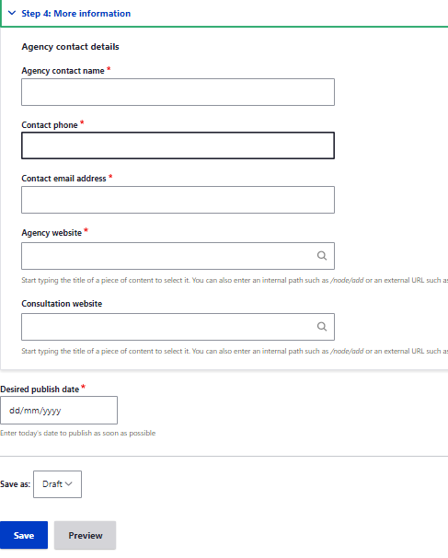

Click SAVE

Editing your Consultation before Submission
If you need to make an edit to your Consultation before you submit it for review, Select DRAFT > Edit content to edit your submission form fields
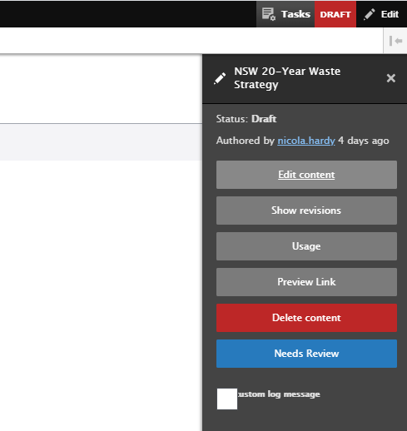

Scroll to the bottom of the submission form and Click SAVE when completed

Submitting Your Consultation for Review
The final step in submitting your consultation is for the content to be reviewed prior to publishing on the Have Your Say webpage by the NSW Digital Channels Team. To submit your consultation for Review:

Click on DRAFT > Needs Review
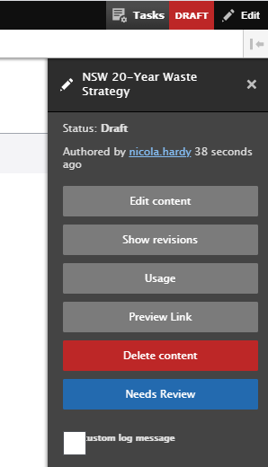

The status will now change from DRAFT to NEEDS REVIEW

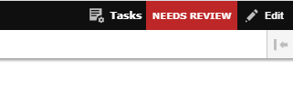
Your Consultation has now been submitted for inclusion on the Have Your Say platform. You will be advised if further details are required or of the publishing date of your consultation on the website.

Have Your Say Admin Support
If you have any questions regarding the Have Your Say consultation system, please click on the below Support Email link to contact the project team.

Support Email

A member of the NSW Government Digital Channels team will come back to you with the answer shortly.

