JJNSW Funded Services Framework

Executive Summary:
Juvenile Justice (JJNSW) funds a range of services to provide supports to young people in relation to areas of risk and need.
The JJNSW Funded Services Framework enables effective and collaborative interagency relationships and diverse funding models whilst providing a service system that responds to individual needs.
The Framework is informed by the JJNSW Priorities and Core Business and Human Rights-Based Principles.
The Framework supports the JJNSW Funded Services Policy, JJNSW Funded Services Procedure (Referral, Review and Exit) and JJNSW Funded Services Guidelines to reflect the application of consistent referral management application, accountability and best practice.

DOCUMENT DETAILS
Version:
Policy Reference: Maintained by: Status:
JJ Funded Services Framework OED (Funded Services)
Draft 3 – Final
Ensure that this document is the latest version to use

JJNSW Funded Services Framework:
The NSW Department of Premier and Cabinet have established principles to support the funding relationship between the Government and funding recipients. The JJNSW Funded Services Framework is informed by these principles and integrated with strategic priorities and core business as follows:

- Safety, culture and practice
JJNSW
Priorities
JJNSW
Core Business
Application Principles
4.
Policy Framework

3.
Application Principles
2.
JJNSW
Core Business

1.
JJNSW
Priorities
- Aboriginal engagement
- Accountability
- Continuous improvement

- Person centred approach
- Effective practice
- Professional Discretion
- Collaboration & Cooperation

- Consistency & coordination
- Diversity & fairness
- Integrity & transparency
- Probity & value for money
- Flexibility & responsiveness

- JJNSW Funded Services Policy
- Referral, Review and Exit Procedure
- JJ NSW Funded Services Guidelines

Referral
Review
Exit
  - JJ Funded Services Continuum

The funded services framework is established to:
- enable the effective use of collaborative interagency relationships and diverse funding models
- allow for a service system that responds to individual needs
- support choice, portability and flexibility that reflects best practice
- ensure accountability for systems that are transparent.
Services funded by JJNSW are required to have a strong outcomes focus and service providers will be held accountable for achieving the agreed outcomes for individual young people. To ensure agreed outcomes are being met services funded under this document will receive ongoing review and monitoring by JJNSW.
The principles provide the foundation for a strong working relationship between JJNSW and the organisations that are contracted to provide services for young people. These principles build on the Principles for the Funding and Working Relationship between Government and Grants Recipients and provide strategic direction for JJNSW to work effectively with funded services.

JJNSW NSW Priorities
Safety, culture and practice: Through the effective and consistent delivery of funded services to meet the individual needs of young people, the JJNSW Funded Services Framework aims to ensure that:
  - our people feel safe and have what they need to succeed
  - we support, encourage and develop our people
  - our programs make life better for young people, their families and community members
  - we include families in our decision making
  - we are leaders in delivering evidence based programs and services to young people involved with the criminal justice system.
Aboriginal engagement: One of the most important issues for JJNSW in NSW is the significant over representation of Aboriginal and Torres Strait Islander young people in both custody and community supervision.
JJNSW funded services seeks to achieve mutual outcomes such as:
  - fewer Aboriginal young people are in custody or on community orders
  - more Aboriginal young people are participating in early intervention and diversionary programs
  - the needs and issues experienced by Aboriginal people are addressed and embedded across JJNSW
  - supporting our people to become more culturally competent.
All employees are supported to build cultural competence, and should regularly familiarise themselves with JJNSW Working with Aboriginal and Torres Strait Islander Young People Good Practice Guide for cultural context and direction when engaging Aboriginal young people and their families.
Accountability: As with any use of public funds, JJNSW is required to ensure transparency and accountability in the allocation of funds to give the community confidence that expenditure is efficient and effective. The effective and consistent delivery of Funded Services ensures that:
  - we implement rights-based systems that support and respect young people
  - young people understand the responsibilities they have as members of the community
  - we reduce recidivism by providing our clients with quality, coordinated services
  - we intervene early to connect young people with family, accommodation and other services
  - our programs are sensitive to individual and cultural needs.
Continuous improvement: To ensure continuous improvement, JJNSW regularly reviews and evaluates the effectiveness of funded services programs and service delivery; identifies good practice; and seeks to build the capability of staff in contract management and financial acquittals.
Through the effective and consistent delivery of funded services the Framework aims to ensure:
  - our operations are sustainable and respond to fluctuating demand
  - our technology and resources enable us to get the job done
  - our structure, systems and culture encourage people to speak out and share ideas for improvement.

JJNSW NSW Core Business
Person Centred Approach: The funded services referral management process is person-centred, so that young people are placed at the centre of decision-making, ensuring that:

- young people and their families are included in decisions and planning which affect them
- young people are supported through a strengths based approach, where young people are able to develop and build on their strengths
- service delivery is responsive to the needs of Aboriginal and Torres Strait Islander young people and young people from a Culturally and Linguistic Diverse (CALD) background
- service is conducted in a manner that is responsive to their cultural needs and context
- service and program delivery caters for all responsivity factors and tailors services appropriately

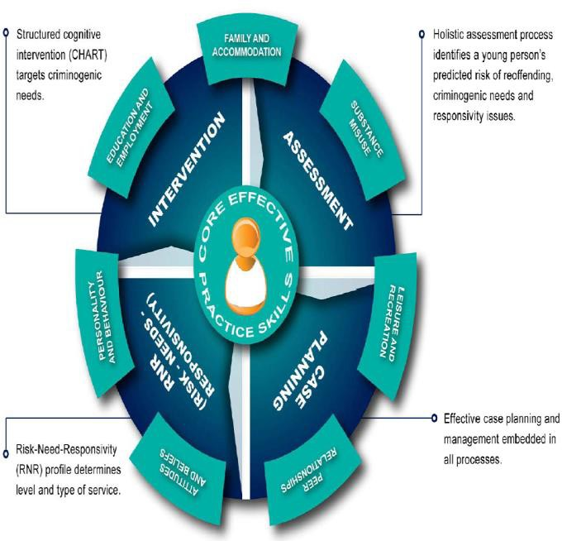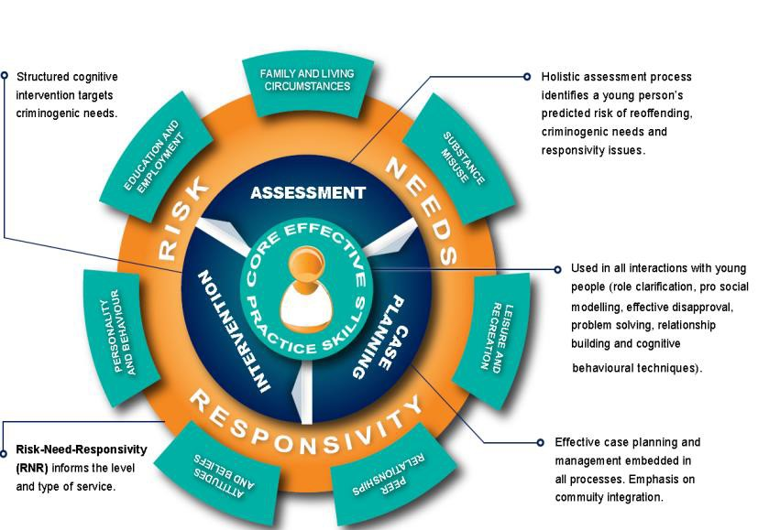Effective Practice: The JJNSW Practice Framework guides JJNSW service delivery and underpins the delivery of case management services and casework support with evidence. It draws together an integrated suite of specific components proven to increase the effectiveness of strategies to reducing the risk of reoffending. The Practice Framework is:
- informed by the evidence base on effective intervention with young people
- addresses risks, needs and responsivity
- responsive to individual needs and multiple entries and exits to the system
- conducive to implementation across NSW with intervention integrity
- supported by ongoing, planned evaluation and continuous improvement
- sustained by training, coaching and ongoing support for workers.

- JJNSW Practice Framework

Professional Discretion: The JJNSW Risk/Need Schedule of Standards articulates that incremental levels of risk correspond with endorsed supervision intensity and direct contact frequency. Direct contact is a face to face meeting between the young person and a Funded Service as detailed in the case plan. Further details regarding the case management of young people in JJNSW can be obtained here.
Professional discretion allows for staff to use local knowledge and expertise in decision making where there are individual characteristics or situations that impact on the assessment outcome. A level of professional discretion should be informed by actuarial risk assessment and determination of referrals and contact frequency with a funded service on a case by case basis and in line with Risk/Need Schedule of Standards.
Collaboration and Cooperation: JJNSW and Funded Services work in collaboration to deliver a range of support services and interventions for young people in contact with the justice system. JJNSW will work collaboratively with funded service providers to promote a relationship that is strengthened through cooperation and reciprocity.
JJNSW will establish and maintain effective strategic partnerships with other JJ service locations, funded services and other community based services. Recognising the importance of mutual goals, co-operation may involve:

  - joint planning exercises at all levels
  - joint research and training
  - mutual respect for each other’s ways of working
  - sharing of information
  - working together to improve service delivery through planning, quality improvement, building service capacity and dissemination of information about practice issues.

Application Principles
The application of the following principles aims to build the self-efficacy of young people involved, and is underpinned by human rights based approaches and JJNSW core principles of effective practice:
Integrity and Transparency: The services funded by JJNSW will be required to meet JJNSW Key Performance Indicators (KPIs). Strategic directions regarding the funding and delivery of services will be made based on the strategic requirements of JJNSW.
As JJNSW is using public funds to purchase services, it is important that it acts in a way that maintains public confidence in procurement processes. This is achieved by using fair and transparent processes that can be clearly documented to demonstrate probity and equity.
To achieve this, JJNSW documents all service acquisition processes, including all approvals from delegated officers, and clarifying consistent and transparent administrative terms and conditions for each Tender process. Feedback is always available to applicants following procurement processes and information on funded services is provided in the JJNSW annual report.

Consistency & Coordination: Funding procedures should be consistent within programs, across individual government agencies, across government and as funding programs evolve. JJNSW seeks to ensure consistency through establishing standardised processes.
In addition to planning and service delivery, JJNSW approaches procurement by strongly promoting co-ordination and collaboration. Recognising the importance of these services is crucial; hence developing relationships is strongly encouraged through means such as interagency and review meetings. JJNSW is strongly committed to these principles and further details are available here.

Diversity and Fairness: The importance of acknowledging and responding to diversity in JJNSW is recognised in funding practice through a range of approaches which include:
- provision of culturally appropriate services for young people with Aboriginal and Torres Strait Islander and/or Culturally and Linguistically Diverse backgrounds
- provision of services targeted to groups with particular needs and initiatives to strengthen sector capacity
- accounting for barriers to service provision in rural and remote areas
- streamlining policies and procedures to ensure consistent and equitable referral management
Probity and Value for Money: Funding administration must be conducted in an environment of integrity, honesty and scrutiny. The conduct of staff involved in the procurement process should also reflect the core values of Justice: Service, Trust, Accountability, Integrity and Respect. Further information can be obtained from the Justice Code of Ethics and Conduct located here.
This is about obtaining the best mix of services to meet the complex needs of young people within the available funding. JJNSW seeks to achieve, or improve, value for money in its funded services operations, using a range of strategies. These include:

- basing service delivery models on evidence of what works
- specifying service eligibility, activities, and measurable outcomes
- using the most appropriate procurement method, based on the characteristics of the service to be provided, the type and level of funding available, the nature of the relevant market, and the expertise of any known providers
- working with Peak bodies and funded service providers to build sector governance and service delivery capacity and improve service systems and operations.

Flexible and Responsive Approach: A flexible and responsive approach to program delivery ensures individualised responses to changing demographics, needs of the target group and priorities of JJNSW. A level of professional discretion allows an appropriate response to any changing demographics, needs of the target group and priorities of JJNSW.
This enables the effective use of different funding models, mechanisms and relationships to allow for a service system that responds to individual needs. Funding programs will support choice, portability and flexibility that uphold the best interests of the young person in all considerations.

Policy Framework

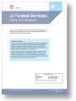
Funded Services Policy: Sets the strategic direction and framework for the engagement of funded services contracted by highlighting the ‘what and why’ relating to our provision specific services to empower young people to reach their potential without offending.

Referral, Review and Exit Procedure: Clarify all ‘who and how’ processes associated with the Referral, Review and Exit of young people engaged with JJNSW funded services to ensure consistency, transparency, accountability, reliable date and accurate records.

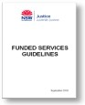
Funded Services Guidelines: Assists the administration of JJNSW funded services with a focus on the roles and responsibilities of staff and an outline of key accountabilities. The guidelines are underpinned by a compendium of resources and appendices to facilitate all business phases of the funded services process.

References:
Legislation
  - Bail Act 2013
  - Children (Criminal Proceedings) Regulation 2011
  - Children (Detention Centres) Regulation 2015
  - Children (Community Service) Act 1987
  - Children (Criminal Proceedings) Act 1987
  - Children (Detention Centres) Act 1987
  - Children and Young Person’s (Care and Protection) Act 1998
  - Privacy and Personal Information Protection Act (1998)
  - Young Offenders Act 1997

Related Documents

  - JJNSW Funded Services Policy
  - JJNSW Case Management Policy
  - JJNSW Funded Services Procedure (Referral, Review and Exit)
  - JJNSW Case Management Procedure
  - JJNSW Funded Services Guidelines
  - JJNSW Schedule of Standards
  - JJNSW Practice Framework

Document information:

Title: | JJNSW Funded Services Framework
Business Centre: | Juvenile Justice (JJNSW) – Office of the Executive Director
Author: | Principal Project Officer – Funded Services Unit
Approver: | Director, Office of the Executive Director
Date of Effect: | August 2017
Next Review Date: | August 2019
File Reference: | 16/05644
Key Words: | Framework, Funded, Services, Procurement, Service

Document history:

Version | Date | Reason for Amendment
01 | 00/00/2015 | New Policy
02 | 06/04/2017 | 2015-2017 Policy review: Changes in response to applying Funded Services Framework and consistent referral management process
03 | 27/0717 | Final - Amended in response to feedback at consultations

