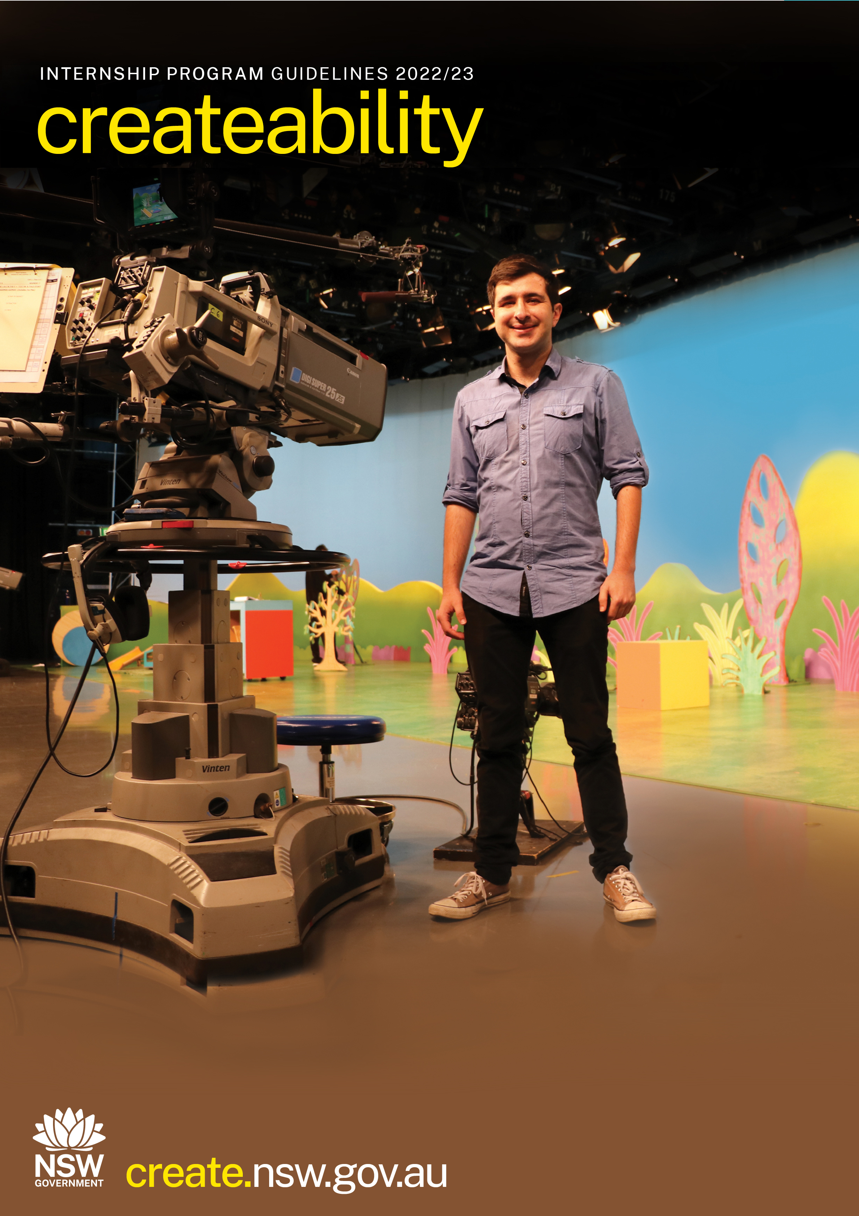

Table Of Contents
Createability Internship Program 22/23 Guidelines 2
Contact Create NSW 2
Accessibility, Inclusion And Other Support 2
Message From The Minister For The Arts 4
Program Overview 5
About Create NSW 5
Who Can Apply 5
Key Questions 6
Key Dates 8
How Do I Apply? 8
Application Assessment 9
Who Should I Contact If I Have Any Questions? 10
APPENDIX A – Information In Other Languages 11
APPENDIX B - NSW Aboriginal Arts & Cultural Protocols 13

Create NSW acknowledges the Aboriginal people across the State and their continued connection to their lands, waters and culture.

We respect Elders past and present and the role that Aboriginal artists play in contributing to their culture.

Contact Create NSW
David Everist Manager (Createability)
T 02 8289 6404 | M 0439 133 712
david.everist@create.nsw.gov.au

Alternatively, you can contact:
Arts queries
Tammy Close
T (02) 8289 6405
tammy.close@create.nsw.gov.au

Screen queries
Amelia Carew-Reid
T (02) 8289 6417
amelia.carew-reid@create.nsw.gov.au

Accessibility, Inclusion and other Support

Create NSW is committed to improving accessibility to the Arts & Cultural Funding Program.

This year, we also have an Easy Read version of the Guidelines available here,

If you are an applicant with disability or who is d/Deaf, and you require this information in a format which is accessible to you, or if you require this information in another language, you can contact us on (02) 8289 6520 between 9am and 5pm Monday to Friday (except on public holidays):
The National Relay service numbers are:
TTY users: Phone 133 677 then ask for (02) 8289 6520
Speak and Listen users: Phone 1300 555 727 then ask for (02) 8289 6520
You may also contact the peak arts and disability organisation for NSW, Accessible Arts.
(02)9251 6499
info@aarts.net.au

Program Overview
This Createability Internship Program is a partnership between Create NSW and Accessible Arts and a range of NSW-based arts, screen and cultural organisations, to develop strong career pathways for people with disability.

Internships, attachments and industry placements for emerging practitioners are well-established pathways to employment in the arts, screen and cultural sectors. This program is a critical step to delivering longer term job placements in the sector as the NSW Government and industry work together in partnership.

The Createability Internship Program will provide customised training for up to 10 participants with disability or who are d/Deaf, followed by paid internships in major NSW organisations across the arts, screen and cultural sectors.

The internships will cover a variety of creative and technical areas in the screen and cultural sectors. This includes opportunities in marketing, curating, production, front of house, arts administration, public programs, art department, camera and sound, writing, producing, animation and visual effects, and editing.

Following the successful pilot program delivered in 2018, Create NSW has committed to running the Createability Internship Program over from July 2021 through to June 2024 (three years). This round is the second of three rounds.

About Create NSW
Create NSW is the major support and funding body for the arts, screen, and culture sector in NSW. Create NSW invests in the success and future of arts, screen and culture in NSW through infrastructure and funding programs.

Who Can Apply?
To be eligible to apply, you need to meet the following criteria:
- be an Australian citizen or an Australian permanent resident
- identify as a person with disability or who is d/Deaf (see below for definition)
- be over 18 years of age
- be a current resident of NSW and;
- have some previous industry experience at an emerging or mid-career level. This could include being new to the workforce or having been actively engaged in or seeking a career opportunity in the arts, screen and culture industry. The program is designed for people who would benefit from an internship, rather than those who are established practitioners.
- applicant was not a recipient of a 2021/22 Createability Internship.

The NSW Disability Inclusion Act 2014 (DIA) defines disability as:
“The long-term physical, mental, intellectual or sensory impairment which in interaction with various barriers may hinder the full and effective participation in society on an equal basis with others.”
The term ‘disability’ can also include d/Deaf or hard of hearing people, people with mental health conditions or chronic illness.

Applicants will not be asked to disclose any medical information. The application form will ask you to list any access requirements you may have.

Key Questions

What sort of applicants will be awarded a Createability intership?

The interns are open to arts and screen workers at any career stage or level of experience. Interns need to show that they have had some involvement, either voluntary or via employment, in the arts or screen sector, but they don’t need to have a significant level of experience to suit this program. Applicants will need to demonstrate that they would benefit from undertaking an internship. People who are already well established in their careers in arts, culture or screen may not be suitable for this internship.

How long will each internship be?

The internships will vary according to the schedule of the organisation and availability of the intern. Internships may be full time (for 4 weeks at 40 hours per week) or part time (up to approx. 20 weeks at one day a week). The hours per day are flexible and can be negotiated in advance, on a case-by-case basis. Up to 160 hours are available per internship.

Can I choose which organisation I intern with?

Yes. As part of your application, you will identify which Host Organisation/s you are interested in working with, from a list of organisations provided. You will be able to select up to three and list them in priority order.

You may also choose another organisation not on the list, provided you have contacted them, and they have agreed to be involved in this program. This would count as one of your three choices. All Host Organisations must be based in NSW.

The list of internships available in a separate document – Appendix C, available on the Create NSW website.

We encourage you to be very clear in your choices and apply for more than one internship opportunity where possible. In the application form, it is a good idea to clearly explain why you have selected a particular internship and demonstrate that you are a good fit for each of the ones you select.

Will I be paid while I am participating in the internship?

Candidates will be paid during the training component of this program and throughout the internship period itself. Wages will reflect current industry minimum standards.

Travel and accommodation costs are not provided through this internship program.

I have access requirements – will there be assistance for me as part of the internship?

Yes. Access will be provided for the interviews for shortlisted applicants.

Prior to starting their internship, each of the successful interns will be matched with a Host Organisation. A work program will be developed based on the skills and interest of the participants, alongside the opportunities and requirements of the organisations.

Interns will be provided with bespoke job-ready training, delivered by Create NSW and Accessible Arts.

The Host Organisations will be provided with customised Disability Confidence Training facilitated by Accessible Arts.

Both the interns and Host Organisations will receive support and mentoring from Create NSW throughout the duration of the internships.

Interns will need to provide information on their access requirements in the application form and interview process. Access requirements for the internship period will be supported via the Employee Assistance Fund (run by Job Access) and/or the Host Organisations. For anyone needing support via Job Access and the Employment Assistance Fund, they would need to work a minimum of 8 hours a week for at least 13 weeks.

When will the internships be run?

The internship commencement dates will be determined by the schedule of the organisation and the availability of the intern, but they are likely to take place between December 2022 and June 2023.

How do I know what makes a competitive application?

The best applications will be those that clearly address the selection criteria and provide good responses for all the questions asked in the application form.

Arts Activated will be running a webinar about this program online on 7 September. To find out more about the webinars go to the Create NSW website.

Two webinars were delivered in 2021 as part of this program, view them by clicking on this link.

What should I include in my CV?

You can submit either a biography or a CV as part of your application’s support material. This should relate to your experience in the arts, culture or screen sector and should show what you’ve done in terms of employment, voluntary work and training.

Who should I list as a referee?

Ideally this would be someone who you have a professional relationship with and who is aware of what you’re like as a person in a work or voluntary context, someone that can speak to your experience or work readiness.

Key Dates
- Intern applications open on SmartyGrants system – Monday 22 August 2022
- Intern applications close – 5pm Monday 26 September 2022
- Intern interview dates – Monday 31 October, Tuesday 1 November and Wednesday 2 November 2022
- Internship recipients and Host Organisations announced – early December 2022
- Intern training day – Monday 12 December 2022
- Internships take place – December 2022 through to June 2023

Please make a note of these dates, as all shortlisted interns will need to attend an interview and all successful interns will need to attend the training day.

How Do I Apply?

While we encourage the submission of applications using our online application form (available from 22 August 2022), you can submit your proposal in any format accessible to you. For example, this might include email, audio file, video, handwritten or printed document.

If you choose to submit a video application, it does not need to be a professionally edited clip, it can be as simple as a video shot on an iPhone. There is a Create NSW webinar about how to submit a video application here.

If you choose to submit a written application, you are welcome to use dot points to address the questions.

This year, we also have an Easy Read version of the Guidelines available here, as well as an Easy Read version of the application form (please contact David Everist for an Easy Read application form at David.everist@create.nsw.gov.au)

We do ask all applicants to provide the following information with their submission:
- Contact Details:
    - Name
    - Date of Birth
    - Address
    - Contact phone number
    - Email address
- CV or short bio – including details of relevant work, volunteer and study experience and/or qualifications.
- Do you identify as a person with disability or d/Deaf?
- Outline any support and/or access requirements you may have.
- Outline your previous work and/or volunteer experience as it relates to the arts, culture or screen sectors.
- Summary of formal or informal training and employment you have been involved in.
- What do you hope to get out of the Createability Internship and why do you believe it would be of value to you at this point in your career?
- Description of the type and/or area of work you might be interested working in. This could include identifying one or more of the Host Organisations and internship opportunities listed in these guidelines, or another organisation you are interested in working with.
- Details of two independent referees who can speak to your suitability for this program.

How do I submit my application if I’m not using the online application form?

All applications should be addressed to David Everist Project Manager of the Createability Internship Program, david.everist@create.nsw.gov.au

Please contact us if you need to submit your application via an alternative method. An Easy Read version of the application form is also available, please contact David Everist for this version.

Application Assessment

Applications will be assessed by a panel of Create NSW and Accessible Arts staff, including people with disability or who are d/Deaf.

Shortlisted applicants will progress to an interview stage before final selection of the interns are made.

Interviews will be facilitated by Create NSW staff, with Accessible Arts and Host Organisation staff also in attendance.

Selection Criteria

The following selection criteria will be used by the assessment panel to assess Createability applications:

1. The skills, achievements, and experience of the applicant in relation to being "work ready" for an internship.

2. The potential effectiveness of the professional development opportunity provided by the Createability Internship in helping the applicant to build relevant industry skills.

Who Should I Contact If I Have Any Questions?

If you require any clarification, please contact Create NSW between 9am and 5pm Monday to Friday:

David Everist Project Manager
Email: david.everist@create.nsw.gov.au

Arts queries
Name: Tammy Close
Phone: (02) 8289 6405
Email: tammy.close@create.nsw.gov.au

Screen queries
Name: Amelia Carew-Reid
Phone: (02) 8289 6417
Email: amelia.carew-reid@create.nsw.gov.au

OTHER INFORMATION
The following further information can be found on the website: create.nsw.gov.au
- Complaints process
- Privacy Policy
- Government Information (Public Access) Act 2009

DISCLAIMER
Every effort has been made to ensure that this publication is free from error and/or omission at the date of publication. The authors, publisher and any person involved in the preparation of this publication take no responsibility for loss occasioned to any person acting or refraining from action as a result of information contained herein.

APPENDIX A – Information In Other Languages
Arabic
إذا كنت تحتاج إلى هذه المعلومات بصيغة أسهل للقراءة أو بلغتك الأم، أو إذا كنت تحتاج إلى مساعدة في تقديم طلبك، يُرجى الاتصال بنا بين الساعة 9 صباحاً و5 مساءً من الإثنين إلى الجمعة

Traditional Chinese
如果您需要我們以更容易獲取的格式或您的母語提供這些資訊，或者您在申請中需要任何幫助，您可以在週一至週五上午9時至下午5時之間同我們聯絡

Simplified Chinese
如果您需要我们以更容易获取的格式或您的母语提供这些信息，或者您在申请中需要任何帮助，您可以在周一至周五上午9时至下午5时之间同我们联系

Filipino
Kung kailangan mo ang impormasyong ito sa madaling ma-access na format o sa iyong unang wika, o kung kailangan mo ng anumang tulong sa iyong aplikasyon, maaari kang makipag-ugnay sa amin sa pagitan ng ika-9 ng umaga at ika-5 ng hapon Lunes hanggang Biyernes

Greek
Εάν χρειάζεστε αυτές τις πληροφορίες σε πιο προσιτή μορφή ή στην πρώτη σας γλώσσα, ή αν χρειάζεστε βοήθεια με την αίτησή σας, μπορείτε να επικοινωνήσετε μαζί μας από 9πμ έως 5μμ, Δευτέρα έως Παρασκευή

Hindi
यदि आपको यह जानकारी अधिक सुलभ प्रारूप (फॉर्मेट) में या अपनी पहली भाषा में चाहिए, या यदि आपको अपने आवेदन के साथ किसी भी सहायता की आवश्यकता है, तो आप सोमवार से शुक्रवार सुबह 9 बजे से शाम 5 बजे के बीच हमसे संपर्क कर सकते हैं।

Italian
Se hai bisogno di queste informazioni in un formato più accessibile o nella tua prima lingua, o se ti serve assistenza con la domanda, puoi contattarci dal lunedì al venerdì tra le 9 e le 17

Korean
열어 보기 쉬운 포맷이나 본인의 모국어로 이 정보를 보고 싶거나, 신청 과정에 무슨 도움이라도 필요하시면 월요일부터 금요일 오전 9시부터 오후 5시 사이에 연락하시면 됩니다

Macedonian
Ако оваа информација ви треба во подостапен формат или на вашиот прв јазик, или ви треба помош околу вашата апликација, може да нé контактираме меѓу 9 наутро и 5 попладне од понеделник до петок.

Portuguese
Se necessitar desta informação num formato mais acessível ou na sua língua materna, ou se necessitar de qualquer assistência com o seu pedido, pode contatar-nos entre as 9:00 e as 17:00 horas, de segunda a sexta-feira.

Spanish
Si necesita que esta información esté en un formato más accesible o en español, o si necesita asistencia con su solicitud, puede ponerse en contacto con nosotros de lunes a viernes entre las 9 y las 17 hrs.

Thai
หากคุณต้องการข้อมูลนี้ในรูปแบบที่สามารถเข้าถึงได้ง่ายขึ้นหรือเป็นข้อมูลในภาษาแรกของคุณ หรือหากคุณต้องการความช่วยเหลือเกี่ยวกับใบสมัครของคุณ คุณสามารถติดต่อเราได้ วันจันทร์ถึงวันศุกร์ ระหว่างเวลา 9.00 น. ถึง 17.00 น.

Turkish
Bu bilgilere daha erişilebilir bir formatta veya ana dilinizde ihtiyacınız varsa veya başvurunuzla ilgili herhangi bir yardıma ihtiyacınız varsa, Pazartesi-Cuma günleri 09:00-17:00 saatleri arasında bizimle iletişime geçebilirsiniz.

Vietnamese
Nếu quý vị cần thông tin này ở dạng dễ đọc hơn hoặc bằng tiếng mẹ đẻ của mình, hoặc nếu cần được trợ giúp về bất cứ điều gì với đơn xin của mình, quý vị có thể liên hệ với chúng tôi trong khoảng thời gian từ 9 giờ sáng đến 5 giờ chiều, từ Thứ Hai đến Thứ Sáu

APPENDIX B - NSW Aboriginal Arts & Cultural Protocols
Create NSW plays an important role in supporting the NSW Aboriginal cultural sector through providing direct investment through funding programs, developing strategies and policies for cultural development and advice and guidance to Aboriginal artists, arts workers and organisations.

Create NSW acknowledges that a strong and vibrant Aboriginal cultural sector starts with supporting self-determination for the Aboriginal sector to manage, maintain and preserve Aboriginal cultures and ensure that the right way to do cultural business is supported, understood and acted on.

With the Aboriginal Arts & Cultural protocols, Create NSW seeks to work with the Aboriginal cultural sector to champion a new body of practice that has Aboriginal self-determination and Aboriginal cultural authority and agency at its foundation.

Just as Aboriginal culture is living and continues to evolve, these Protocols have been developed to be a living document. Create NSW will continue to work with the NSW Aboriginal cultural sector to update the protocols annually to ensure that the continued growth and new and emerging areas are covered.

The Protocols can be found at create.nsw.gov.au/arts-in-nsw/aboriginal-arts-and-culture-protocols/

Cover Image: 2018 Createability intern Joel Pragnell on the set of ABC’s Play School.
Image: courtesy Joel Pragnell

