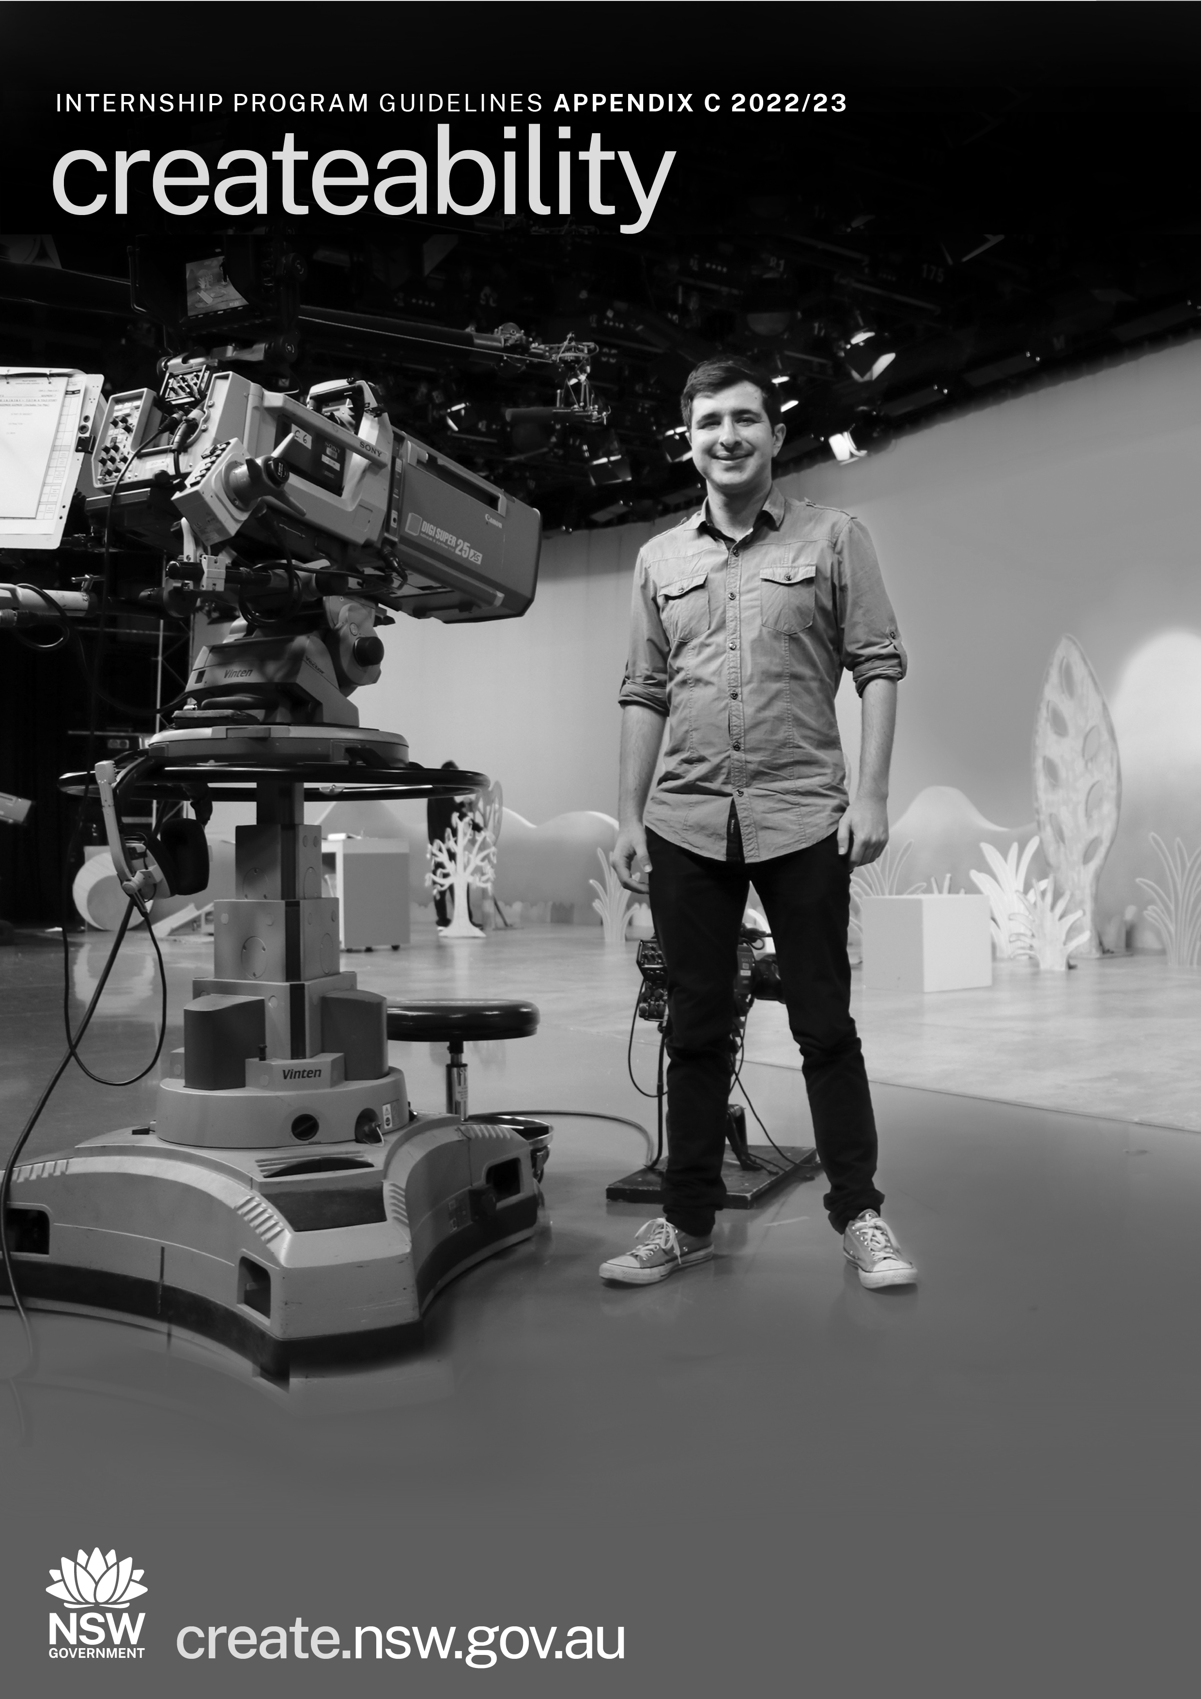

APPENDIX C - Available Internships

For the 2022/23 Createabilty Program, the following internship opportunities are available:

*Please note, these are a guide only and the exact internship opportunities are subject to change, pending COVID restrictions and organisational planning.

The application form will ask you to select up to three Host organisations you’re interested in working with. It will then ask you to explain why you are interested in working on these specific internship opportunities.

Internship opportunities available

Arts/culture organisations
Cementa Inc (based in Kandos)
cementa.com.au

Cementa is a unique, regionally situated, socially engaged, artist-led residency and contemporary art festival platform. The intern will be working in an unconventional arts and culture context, outside of the gallery system, in a role that will engage them with a regional organisation and a local community. The internship will work either as a community liaison or a youth engagement officer but alternatively applicants who are interested can work in marketing, fundraising, general administration or project management. There is also a potential for an applicant to work in an administrative role in coordination with the Artist Run Initiative committee for WAYOUT ArtSpace.

There is the opportunity to work remotely for an intern that does not live in the local region with regular trips to Kandos for direct involvement with our operation. This would be supported by travel and accommodation support provided by Cementa.

Sydney Opera House
sydneyoperahouse.com

The Sydney Opera House is an architectural masterpiece and vibrant performance space, where the past shapes the future, where conventions are challenged and cultures are celebrated. It is offering the opportunity of an internship with the Recording and Broadcast team. This will be a hands-on involvement with the pre-production, production and postproduction of a large-scale broadcast event (VIVID Live 26 May – 17 June 2023). VIVID Live as a program offers a variety of opportunities over the course of a few weeks to engage in the filming and editing of events. Specialist knowledge of editing programs is not required.

Varuna - The National Writers House – located in Katoomba
varuna.com.au

Varuna is recognised as Australia’s pre-eminent institution for writing development and is central to a thriving writing community. Each year, over 150 writers participate in residencies and professional development programs at Varuna, and many hundreds more readers and writers participate in workshop programs and literary events, including the annual Blue Mountains Writers’ Festival. The intern will work alongside program and admin staff and will liaise directly with the Executive Director and Creative Director. The internship will assist with marketing and programming and will help with the roll out of Varuna’s specialised program for writers with disability, The Writer’s Space. They will also assist in marketing tasks across Varuna’s full range of programs and fellowships.

Sydney Festival
sydneyfestival.org.au

Sydney Festival is offering two options for the internship within the Marketing team or the Programming team. The roles will be part-time, beginning in December and ending in January.
1. The Marketing role will report directly to the Marketing Director. They will work closest with the Digital Marketing Manager and the Marketing Coordinator supporting digital activity across website, email, social media and assisting with cross promotions.

2.The Programming role will report directly to the Head of Programming Operations. They would work closest with the Programming Coordinator and the Associate Producer to prepare and deliver the 2023 Access Program and organise the hospitality for all artists and companies.

Legs On The Wall
legsonthewall.com.au

Legs On The Wall is a leading physical theatre company built on camaraderie and a shared vision to make the impossible possible. The intern will assist the management team with digitising and filing archival materials (video, slides and other records) from Legs near 40-year history of artistry and performance. This will involve identifying and curating particular highlights from these assets, and helping to form strategies for celebrating the company's history, looking ahead to its fortieth anniversary in 2024.

There is also scope for assisting with initial forward planning of Legs' 40th anniversary events, online strategy and content creation, as well as an advocacy role, identifying gaps in Legs' cultural legacy, and suggesting avenues for consideration for future programming.

The role can be calibrated to best suit the skills and interests of an enthusiastic applicant. This is an administrative role working initially with the Legs team in our Lilyfield office, with scope for achieving some tasks working remotely.
Sydney Dance Company
sydneydancecompany.com

Sydney Dance Company is offering two options for the internship of a Learning Assistant role and one within the Marketing, Communications and Partnership team.

1. The Learning Assistant role will sit within the Learning team supporting the delivery of education and training programs including national school matinee performances, national school and community workshops and other in person and digital education or training related programs. The position supports the successful delivery of these activities for schools, teachers and students and across primary, secondary and advanced training levels at Sydney Dance Company. It is suggested the role would commence 16 January and be 2 days per week until 10 March.

2. The role within the Marketing, Communications and Partnership team will support the delivery of marketing, communications and partnerships activities for performances, classes, advanced training, and venues. The position supports the development of content for campaigns for all channels, including paid and owned media. It is suggested the role could be intensive or over a period of time across the year.

Australian Chamber Orchestra Pty Ltd
aco.com.au/

As one of Australia's finest performing arts companies, the Australian Chamber Orchestra collaborates with an extraordinary range of artists. ACO are offering an internship that will provide experience across the organisation and include opportunities to work on the delivery of a live production with access to back-of-house, front-of-house, producing and administrative roles. The internship is designed to provide broad exposure to working in a leading performing arts company but can be structured to focus on areas of interest and expertise. The internship will be available on various dates from May – July 2022, to be negotiated with the successful applicant.

Musica Viva Australia
musicaviva.com.au

Musica Viva are offering an internship between December/January and June to join the Development and/or Education team, based in Sydney. The Intern will report to a Manager in the team and will work very closely with all members of the team. The internship is intended to provide exposure to a wide range of areas and may include the following: Tessitura data management; Donor and prospect research; Musica Viva Schools Program.

This opportunity can be scaled and structured according to the experience of the intern. Training in how to use Tessitura will be provided. There is no requirement to interact directly with donors or external stakeholders. Ideally, the intern will be able to commit to working over 3 to 6 months to ensure they can participate fully and get the most benefit. The intern will need to be proficient in Excel and Word and Outlook. A passion for data and research and good organisation skills will be highly regarded.

Sydney Theatre Company Ltd
sydneytheatre.com.au

Sydney Theatre Company (STC) is looking for an intern who has a passion for Australian theatre and wishes to learn more about the behind-the-scenes and potentially develop their career in the theatre. The placement will provide exposure to areas of the intern’s interest. These areas could include Front of House, Box Office, Marketing, or our back of house departments including Production (e.g. Costume), Technical (e.g. Lighting), or Stage Management. Please note that availability of work areas may be subject to availability and scheduling, however STC will endeavour to place interns in areas that match their interests. Please also note that some of our opportunities could potentially include working at night, though this would not be mandatory.

Create NSW
create.nsw.gov.au/
Create NSW, the major support and funding body for the arts, screen, and culture sector in NSW internship opportunity will be within the Arts Funding and Development team. The successful applicant will see how funding works behind the scenes and gain valuable insight into the coordination of the Small Project Grants (Quick Response) funding round which supports emerging, midcareer, and established artists to peruse time-sensitive opportunities. An intern at Create NSW will develop skills across assessment, communication, stakeholder engagement and administration as well as useful knowledge of the SmartyGrants system.

Screen organisations
Northern Rivers Screenworks Inc
screenworks.com.au/

Northern Rivers Screenworks will tailor the learning outcomes of specific interest to the intern with the options to look at gaining experience in social media and marketing, membership operations and retention, research and developing events, workshops and programs, helping to set up awards programs, and other general administrative support. There are also other areas within the organisation the intern could explore if they meet specific interests. Screenworks recommends that if an intern is interested in working at Screenworks, they would like to sit down to discuss their career goals and establish a learning outcomes-focused plan to get the most out of the intern opportunity.

Bronte Pictures
brontepictures.com

The role with Bronte Pictures will be a Production Assistant, assisting production in various tasks and activities as required to complete each scheduled day to day work. The intern will have the opportunity to assist all departments with their requirements. For the most part it will be an office-based job with some days on set. Bronte Pictures will do an assessment with the intern to decide the best types of work to undertake. Tasks will be assigned and worked through with the support of a team. There will be the opportunity to see the creative side to making a film and see how the departments put the sets/costumes and hair and makeup together to make a script come to life.

Animal Logic Pty Limited
animallogic.com

Animal Logic is is offering two options for the internship within production and as a digital artist.

1. The production intern will be part of a team that is responsible for the efficient, day-to-day facilitation of processes, procedures, outputs and deliverables of digital artists. In partnership with the department supervisor/lead they are also responsible for motivating a team of artists, increasing efficiency, and streamlining processes where appropriate. A production intern will gain exposure to production, as well as tools to support the projects, including excel, project and other industry tools.

2. A digital artist intern will be part of the team that supports the day-to-day generation of assets/shots to a creative or technical brief in support of the Director’s vision. The digital artist should ensure there is a consistent level of quality and delivery within established timelines. A digital artist can be specialised to a specific department (eg Art, Animation, Editing) or work more broadly as a generalist.
A digital artist intern may be given hands on experience aligned to the department they will work within.

Australian Broadcasting Corporation
about.abc.net.au/
abc.net.au/religion/watch/compass/

ABC is is offering two options for the internship as Production Assistant or Compass intern researcher.
1. Production Assistant role will, under supervision, contribute to the ABC Children’s Originals team and tasks as a Production Assistant. It is an entry level position and limited prior experience is required. ABC Children’s offers the successful recipient the opportunity to work on its Original Productions slate. This includes being a part of the life cycle of a commissioned production, including but not limited to script meetings, brainstorms, research, shoots, the post-production pipeline as well as intersecting with other departments. The recipient will be assigned a buddy and leader for their growth, development, belonging and open communication.

2. Compass intern researcher will join the team behind long running Religion & Ethics program Compass, as an intern working closely with TV researchers and producers to research Compass episodes, identify on camera talent or provide factual details to enhance the story. Ideally the intern will have strong research skills, and an interest in TV. Prior experience or training in TV making a plus, but not essential. Key duties will be to develop and research story ideas, identify talent, archive material, filming opportunities, locations and creating social media assets.

ABC Ultimo is an accessible building, and there is the opportunity for hybrid and flexible working arrangements, including flexible working hours and accessibility requirements.

Industrial Light & Magic (Australia) Pty Ltd
ilm.com/locations/sydney/

The ILM Visual Effects Global Production department is responsible for strategic oversight of all visual effects at the studio, including work on Star Wars and other IP in feature films. Working out of ILM's Sydney studio, the intern will provide administrative and back up support to the VFX production team working on various projects while gaining an opportunity to learn about the production environment and process at ILM. The VFX Intern will primarily take direction from the Production Manager and will handle a variety of administrative, research, special projects and various tasks related to VFX Production on any of the projects under the VFX Umbrella described above. The VFX Intern may have dedicated time on a particular project or may help as needed across the breadth of projects in production.

A general understanding of the film and VFX process, with a desire to work in the industry.

Endemol Shine Australia Pty Ltd
endemolshine.com.au/

ESA is offering two internship positions to assist Content Producer and in scripted development.
1.The intern will assist the Content Producer and Content AP in their roles of selecting the material to be edited and sent to the field each week. This includes watching content as directed by the producer, assisting the content AP in maintaining the content log and sending it to the Line Producer weekly, assist in the edit of the shows each week and sending them to the field.
Area of Organisation: Gogglebox Series 17, production department

2. Scripted Development Intern will work closely and collaboratively with the Drama Development team including Sara Richardson, Head of Scripted. The candidate will be actively involved in, and across all scripted drama projects throughout their various stages, from development through to production, post-production and completion. This includes scripts, creating pitch materials, assisting with funding applications, participating in brainstorming and gaining an administrative understanding of company and industry business practices that are essential to the development process.
Area of Organisation: Scripted Development

Other Host Organisations
You may also propose to work with a different Host Organisation, provided you have been in touch with them and they have agreed to be part of this program. All Host Organisations must be based in NSW.

Cover Image: 2018 Createability intern Joel Pragnell on the set of ABC’s Play School.
Image: courtesy Joel Pragnell

