CAMPAIGN SUMMARY TABLE

Project Name | Insert project name | Briefed by | Insert name
Project number | Insert project number | Date | Insert date
Department/agency | Insert cost centre | Contact details | Insert phone / email
P.O# / 4 Digit Code | Insert PO or <$250k code | Creative agency | Insert creative agency
Budget | Specify incl/excl fees + GST | Campaign Live Date – Finish Date | Insert campaign timings
Markets  Metro: Regional | Insert markets here  Include split if available | Facebook Approval* | ☐ Have OMD received approval?
Multicultural and  Aboriginal Audiences | First Nations audiences:  ☐ Aboriginal and Torres Strait Islander peoples  Multicultural audiences,  spoken languages:  ☐ Mandarin ☐ Arabic  ☐ Cantonese ☐ Vietnamese  ☐ Hindi  ☐ Greek ☐ Spanish  ☐ Nepali ☐ Italian ☐ Korean  Other languages (if any): | Translation  Min 9% commitment requirement | ☐ Are OMD translation services required? (costs apply as out of scope)  Please specify the reason if the campaign is not meeting the 9% policy requirement.  Enter here

All NSW Government agencies must consider the needs of regional and rural NSW communities in their media planning:
- Allocate at least 26% of campaign media expenditure to reach regional communities.
- Media expenditure to reach regional communities should include independent and local print media advertising.
- Regional press allocations and instructions were included in your agency annual advertising budget emails, please ensure you address this requirement within the brief
- For campaigns over $250,000, agencies must account for their expenditure and ensure that it meets regional reach requirements.
All NSW Government agencies must consider the needs of multicultural and First Nations communities in their media planning:
- From July 2024, at least 9% of an advertising campaign media budget is to be spent on direct communications to multicultural and Aboriginal audiences.
- Spend may be on advertising (paid media) or non-advertising communications activities (e.g. events).
- Spend under the policy does not include the costs for creative, production of paid media assets, translation, or research.
- Please find more information about how to apply this policy on the NSW Government website

Please note: agencies must provide pre-approval from social@customerservice.nsw.gov.au in order to use the NSW Government official facebook page: Facebook for advertising campaigns.

CAMPAIGN TIERING QUALIFIERS
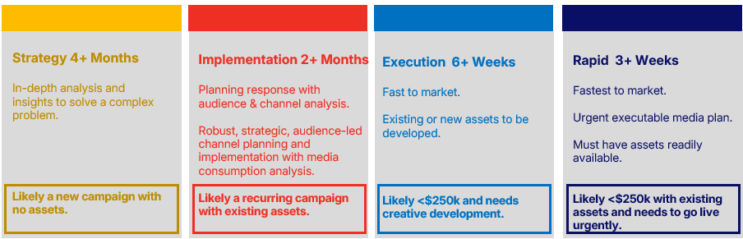

Please mark which tier your brief sits in most suitably based upon the following criteria, noting only ONE tier can be selected.
Please Note: Time to market is indictive and relies on factors such as creative being available when appropriate and prompt feedback and approvals. If multiple Execution and Rapid briefs are received at the same time from an agency, the timing of responses may require adjustment.

☐ Strategy 4+ months  brief to market - minimum | ☐ Implementation 2+ months  brief to market - minimum | ☐ Execution 6+ weeks brief  to market - minimum | ☐ Rapid 3+ weeks brief to  market - minimum
BRIEF SECTIONS TO COMPLETE  All | BRIEF SECTIONS TO COMPLETE  All | BRIEF SECTIONS TO COMPLETE – minimum  Campaign Summary Table + Sections 2, 5, 9 (if assets are available) and 11 | BRIEF SECTIONS TO COMPLETE - minimum  Campaign Summary Table + Sections 2, 5, 9 and 11
OMD DELIVERABLES  - Timeline  - Media Strategy / Approach (PowerPoint)  - Implementation recommendation including audience analysis (PowerPoint)  - Campaign R&F (OMNI)  - Channel Block Plan  - Media plan | OMD DELIVERABLES  - Timeline  - Implementation recommendation (PowerPoint) including Audience analysis  - Campaign R&F (OMNI)  - Channel Block Plan  - Media plan | OMD DELIVERABLES  - Timeline  - Channel rationale, topline audience analysis if required (Word or PowerPoint)  - Media plan | OMD DELIVERABLES  - Timeline  - Basic channel rationale (Word or Email)  - Media plan
PEER REVIEW LIKELY  Peer Review timing is not included in time to market estimate. | PEER REVIEW LIKELY  Peer Review timing is not included in time to market estimate. | NO PEER REVIEW  Peer Review timing is not included in time to market estimate. | NO PEER REVIEW  Peer Review timing is not included in time to market estimate.
REPORTING  KPI Measurement Table  Go Live Report  Digital Dashboard (self service)  Mid Campaign Report (MCR)  Post Campaign Report  Monthly Reporting | REPORTING  KPI Measurement Table  Go Live Report  Digital Dashboard (self service)  Mid Campaign Report (MCR)  Post Campaign Report  Monthly Reporting | REPORTING  Go Live Report  Digital Dashboard (self service)  Mid Campaign Report (MCR) (if 6 weeks+)  Post Campaign Report  Monthly Reporting (if ongoing) | REPORTING  Go Live Report  Digital Dashboard (self service)  Mid Campaign Report (MCR) (if 6 weeks+)  Post Campaign Report  Monthly Reporting (if ongoing)

1. Critical problem

Strategic market brief background. What are we trying to help solve with this advertising?
Enter here
2. Objectives
What are the key goals for this campaign?  Enter here | What are the measures of success / key metrics?  Enter here
3. Marketing and communications task

What do we want our audience to know, intend and/or do as a result of this campaign?
Enter here

4. Communications approach

As a guide, do you have a point of view on whether you are looking for big ideas, media partnerships, socially enhanced activities, something to cut-through: shock or engage, content, broadcast initiative, experiential etc.?
Enter here

5. Target audience
Who are we trying to influence? Describe them in terms of demographics, attitudes, size and behaviour.  Enter here | What are the key barriers for our audience?  What and who influences their choices?  Enter here
6. Insight/s

What is/are the consumer insight/s that drives this brief? Please provide any relevant research or information you have on the change you are looking to drive.
Enter here
7. Stages of Change / Journey

Where in the stages of change / customer journey are we intersecting and influencing our target?
Enter here
8. Key messages

What are the key messages to be communicated and measured?
Enter here
9. Creative assets – required for Rapid briefs

Are there existing assets that could or should be used as part of this brief?

What creative executions are/will be available? How many different creative executions are being planned? If the execution is new, when will it be ready? Will the creative change during the campaign? Please provide details.?
Enter here

10. Paid, owned and earned

Please advise if there is any existing paid activity or earned program of work. What owned assets are available for this campaign (website, signage etc.?)
Enter here
11. Mandatories

List any mandatory activity requirements for this brief i.e. Channels to consider? Channels to avoid?
Enter here

12. Any other relevant information?
Enter here
The NSW Government Brand, Advertising & Engagement (BAE) can provide advertising services support for this brief/your campaign, including compliance with policies on multicultural and Aboriginal audiences, and digital and advertising best practice. Make your request for assistance or advice via the BAE Service Hub.

